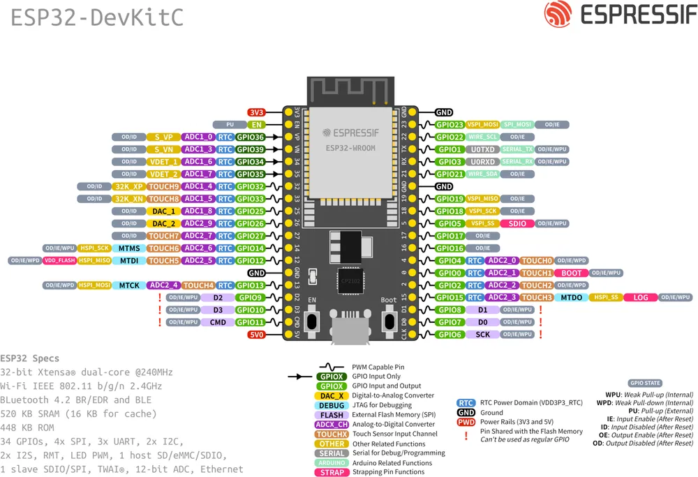
Link to specs.
Use only ADC1 pins (32-39) for analog inputs, as ADC2 conflicts with Wi-Fi !
GPIO |  | Input | Output | Safe? | Notes
0 | Yes |  | Yes | ⚠️ | Boot strapping pin; LOW at boot enters flashing mode
1 | Yes |  | Yes | ⚠️ | UART TX (serial programming/logs)
2 | Yes |  | Yes | ⚠️ | Strapping pin; must be sane during boot
3 | Yes |  | Yes | ⚠️ | UART RX
4 | Yes |  | Yes | ⚠️ | Strapping pin; external pulls can break boot
5 | Yes |  | Yes | ⚠️ | Strapping pin; often used as SPI CS safely
6–11 | Yes |  | Yes | ❌ | Connected to SPI flash
12 | Yes |  | Yes | ⚠️ | Flash voltage strapping pin; HIGH at boot may brick startup
13 | Yes |  | Yes | ⚠️ | JTAG by default; otherwise usable
14 | Yes |  | Yes | ⚠️ | JTAG by default; otherwise usable
15 | Yes |  | Yes | ⚠️ | Strapping pin
16 | Yes |  | Yes | ✅ | Good general-purpose GPIO
17 | Yes |  | Yes | ✅ | Good general-purpose GPIO
18 | Yes |  | Yes | ✅ | SPI default SCK
19 | Yes |  | Yes | ✅ | SPI default MISO
21 | Yes |  | Yes | ✅ | Common I2C SDA
22 | Yes |  | Yes | ✅ | Common I2C SCL
23 | Yes |  | Yes | ✅ | SPI default MOSI
25 | Yes |  | Yes | ✅ | DAC capable
26 | Yes |  | Yes | ✅ | DAC capable
27 | Yes |  | Yes | ✅ | Safe
32 | Yes |  | Yes | ✅ | ADC1; excellent analog pin
33 | Yes |  | Yes | ✅ | ADC1; excellent analog pin
34 | Yes |  | ❌ | ⚠️ | Input only
35 | Yes |  | ❌ | ⚠️ | Input only
36 | Yes |  | ❌ | ⚠️ | Input only
39 | Yes |  | ❌ | ⚠️ | Input only

